Client



Web



Server

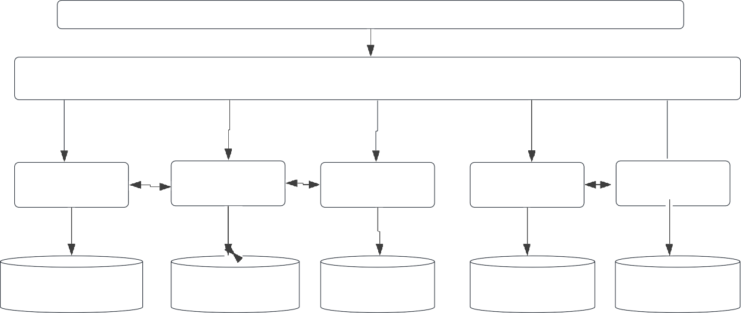

Spring Security

API Gateway

Admin (8084)

User (8087)

Search (8082)

Book (8083)

Payment (8088)

adminDB

userDB

SearchDB

BookDB

adminDB

Eureka

Server

Swagger

MongoDB (Database)

Flight

Book

System